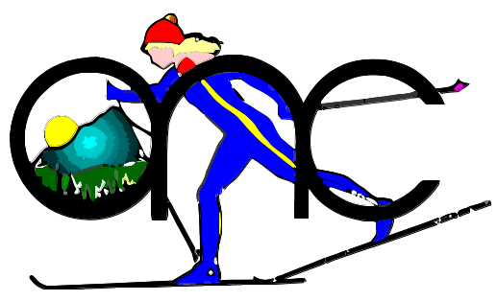
Oregon Nordic Club
Willamette Chapter
oncwillamette.org
P.O. Box 181
Salem, OR 97308

Newsletter
December 2025

After a nice October snow our Cascade weather reverted to rain. No skiing to report for the entire month of November. But snow will come in due course; and while we wait for it there’s a great way to experience another feature of the holiday season—Christmas giving.
Here’s how: last summer the McKenzie River RD had a warehouse fire at their headquarters. Among other losses all the ski gear their staff used to patrol and maintain winter trails was destroyed. Our club can donate equipment to get the rec crew back on the snow this winter. We need 2-3 pairs of skis, boots in women’s size 8-8.5 and men’s 10.5-12 and, of course, ski poles. If you have any excess gear (skis, bindings, boots, poles), please contact Bob Young (530x621x6626) or Jim Todd (503x378x7003). Let’s put a donation package together and keep our dedicated Forest Service staff kicking and gliding this winter.

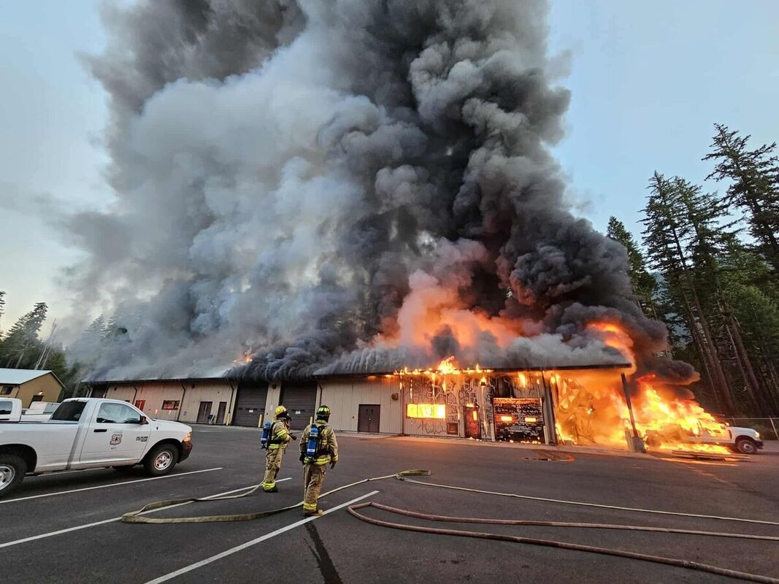
photo by mckenzieriverreflectionsnewspaper.com

WEEKEND DAY TOURS:

Our tour schedule is sparse at present due to Holidays and uncertainties about early season snow conditions. More tours will be added as the season progresses.
Guests are welcome on Willamette Chapter day tours. Please contact the tour leader for details and to ensure the tour matches your interests and skill level.
We need more tour leaders for weekend tours; please step up and lead a tour to your favorite destination. If you wish to lead a tour, suggest a tour destination or learn more about tour leading, contact Jim Todd (503x378x7003).
Remember, impromptu tours are always an option. If you yearn for a day on skis, phone Jim, one the leaders below or a skier on the weekday list. Connect with your fellow Club members and get out when it snows.

December 6, Saturday: if it snows--A Tour, location depending on conditions and group interest. If it doesn’t snow a hike at Silver Falls State Park is on offer. Contact Jeff Starr (503x851x8403).

December 6, Saturday: B Tour, George Miller Memorial Jefferson Park tour. George lead this tour many times when the first snow of the season blanketed the high country. In the unlikely event that it snows this week, contact Jim Todd (503x378x7003).

December 7, Sunday: A Tour, Santiam Pass area. Contact Jeanne Miller (503x588x0473).

December 13, Saturday: A Tour, Santiam Pass area. Contact Jeff Starr (503x851x8403).

December 13 or 14, Saturday or Sunday: B Tour, location depending on snow conditions and group interest. Contact Bob Young (503x621x6626).

December 20 or 21, Saturday or Sunday: B Tour, location depending on snow conditions and group interest. Contact Bob Young (503x621x6626).

December 21, Sunday: A Tour, Santiam Pass area. Contact John Hortsch (503x507x5727).

December 27, Saturday: Beginner/A Tour, Big Springs or Lava Lake SnoParks. Contact Jim Todd (503x378x7003).

December 27 or 28, Saturday or Sunday: B Tour, location depending on snow conditions and group interest. Contact Bob Young (503x621x6626).

January 3, Saturday: B Tour, Ray Benson to Little Nash Traverse; a moderate backcountry route and one of our favorite skis. Contact Jim Todd (503x378x7003).

Tour Ratings: A key to the Tour Rating codes:
“Beginner” = Easy, short distances on flat or gentle slopes; appropriate for first time skiers.
“A” = Easy, distances up to 5 or 6 miles with a few slopes; basic skills are required; some of these may not be suitable for 1st time skiers.
“B” = Intermediate or experienced; distances of 6 to 12 miles or possible elevation gains of 2000 feet; may include steeper sections; some downhill skills are required.
“C” = Advanced, longer with greater elevation gains; includes both trails and off-trail with frequent steep terrain.
“D” = Expert, very difficult or long; possible backcountry travel and/or ski mountaineering.

WEEK DAY SKI TOURS
Why not break the shackles that bind you to the calendar this season? Try a mid-week tour. Contact one of the enthusiasts below and arrange an escape from routine. If you want to be added to this list, send your phone and email to Jim Todd, and we'll include it in the next Newsletter. Likewise, contact Jim, if you want your name removed for this season.

Weekday skiers:
Bill Caldwell 503x385x6494 wbcaldwell1 at q dot com
Chuck Daellenbach 541x928x4256 daellenbachc at comcast dot net
Frank Hoffman 541x475x0185 hh_tex at msn dot com
John Hortsch 503x507x5727 riverjohn at msn dot com
Denise Hughes 435x828x2273 salemhughes at gmail dot com
Peggy Mansfield 503x428x2475 pegevtay2@comcast.net
Bill Nelson 503x576x1278 bnelson at pacificomm dot net
Foxie Proctor 503x581x0207 foxieproctor at comcast dot net
Denise Sanders 503x859x4597 dsander at wvi dot com
Howard Simon 503x569x4299 hsimon6755 at gmail dot com
Jeff Starr 503x851x8403 jeffstarr3 at gmail dot com
Jim Todd 503x378x7003 toddwac18 at gmail dot com
Jerry Vessello 503x931x6344‬ jvess at comcast dot net
Bob Wells 307x203x7930 rawells.evts at gmail dot com>
Craig Wojcik 503x931x2705‬ ccwojcik09 at comcast dot net
Pam Wojcik 971x312x3984 pjwojcik09 at comcast dot net
Bob Young 503x621x6626 arch.byoung at gmail dot com

VOLUNTEER OPPORTUNITIES:
The Willamette Chapter has an active volunteer program assisting the Forest Service with ski trail clearing and marking; shelter construction and maintenance; and firewood stocking. Thank you volunteers! If you have questions about out volunteer projects or would like to join one, contact Jim Todd (503x378x7003).

Volunteer Reports:
December 1&2, Monday and Tuesday; six ONC volunteers joined Detroit RD staff and Salamander volunteers to erect new trail signs at Lava Lake SnoPark. We also limbed encroaching trees and placed blue diamonds on the recently cleared Pumice Loop trail. Ski this area when we have low elevation snow. There are some great trails through a mix of regrowth and towering old growth trees.
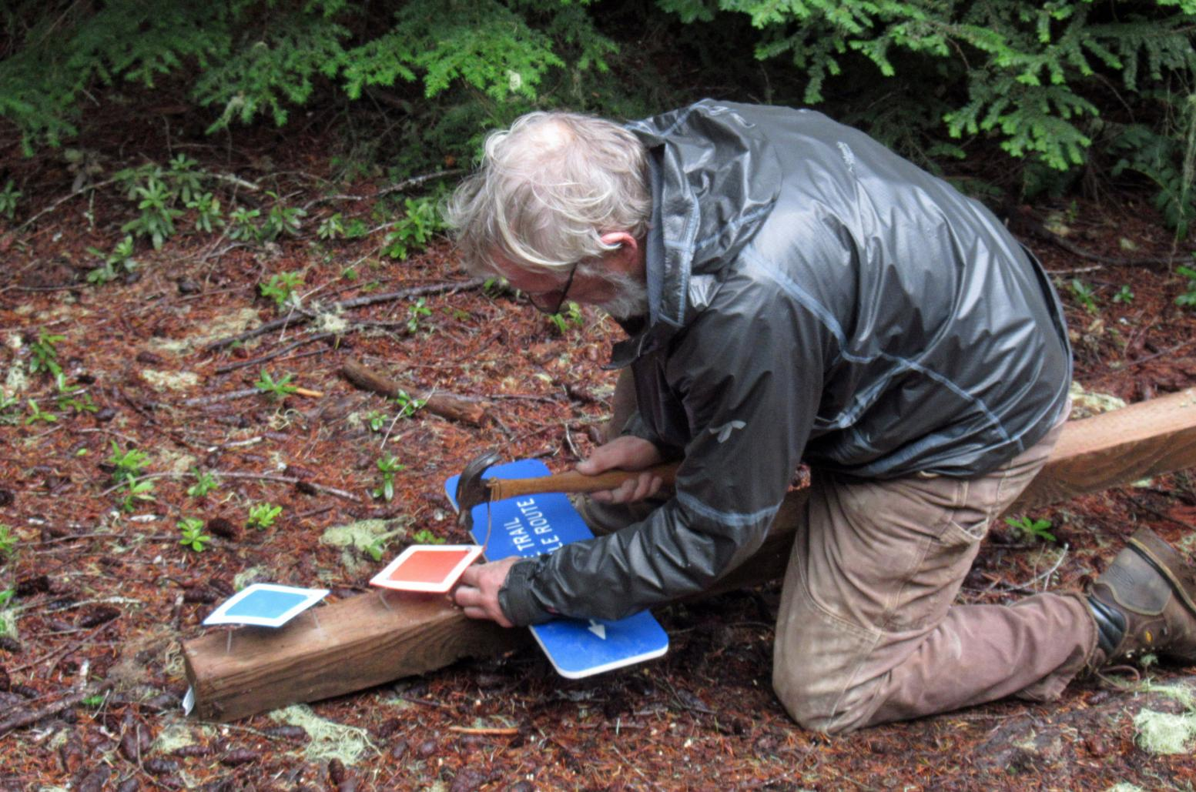
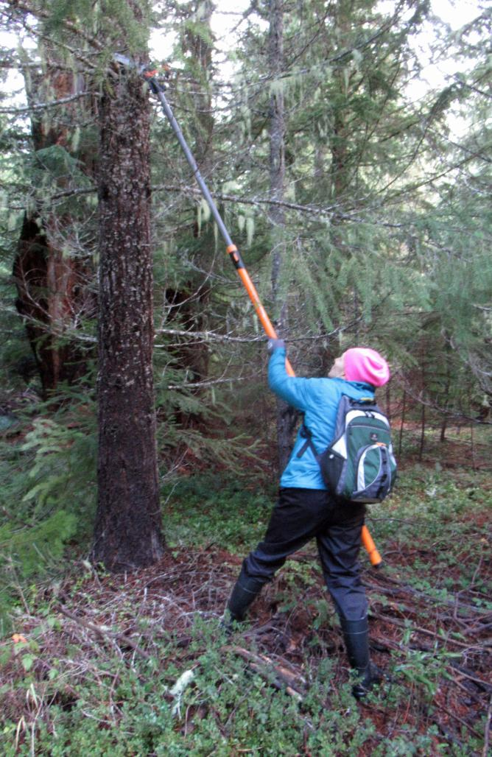
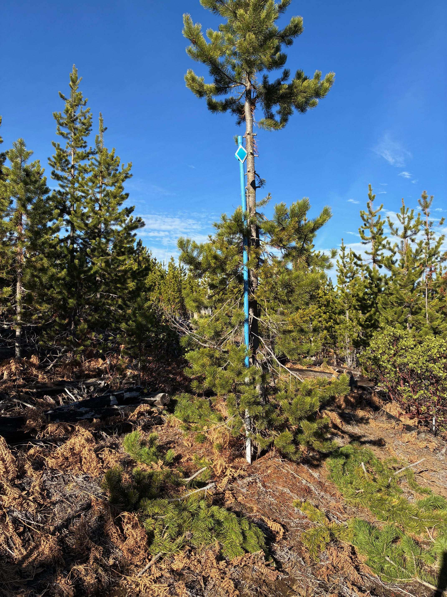
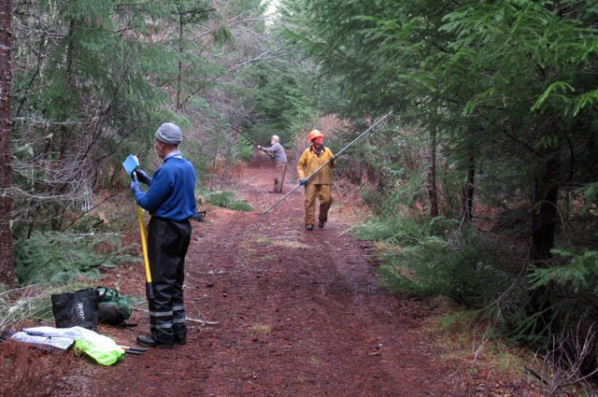
photos by Frank Hoffman

November 22, on a beautiful sunny Tuesday with ½” of snow in the shade I ventured out on the Circle Lake Loop at Ray Benson and started diamond restoration work needed on the recently cleared section from North Blowout to Island Junction shelter. I only got about 1/3 of the trail from the north end started, hopefully with enough diamonds to follow. There’s still a lot of limb removal and diamond work to do but I suspect that will have to wait until next year. I’ll have to try and ski this this year and see if I can find the trail where I’ve lost it the last 2 times I’ve attempted it. The Salamander clearing should really help. Bob Young
NEW SKI TRAIL ROUTE:
This fall Willamette Chapter volunteers relocated a section of the Nash/Potato trail between Little Nash and Potato Hill SnoParks to avoid a steep, overgrown slope that was difficult to ski and sometimes difficult to find. The trail section between roads 725 and 892 was moved west to follow road 723 for a short distance. The new route is marked with signposts where it enters and exits the road—which is groomed snowmobile trail #302, during the winter. The maps below show the changed route. We hope you enjoy this easier ski.

Here’s the official Forest Service map; the route change is just east of Nash Crater where Nash/Potato and Trail #302 nearly touch.

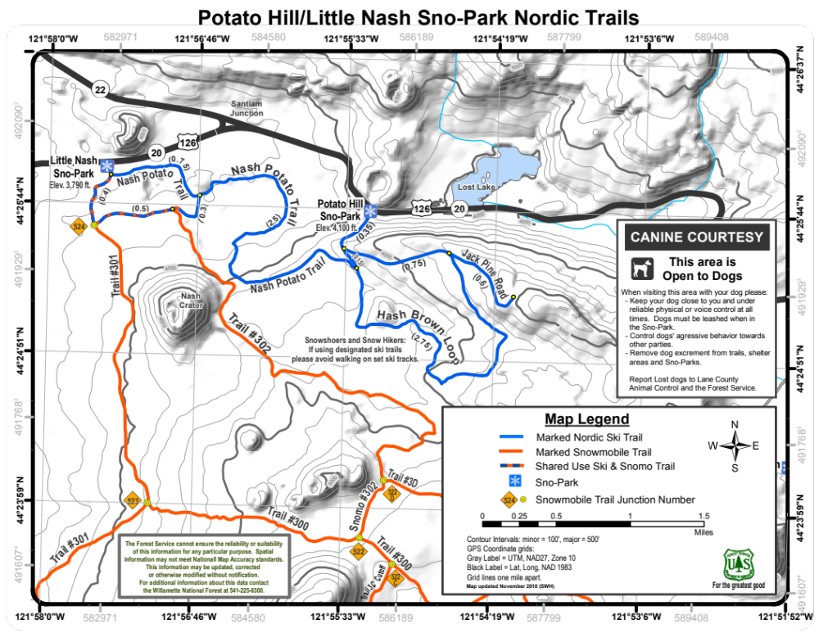

Here’s a close up view: the old route is the green line and the new route, following road 723, is yellow.
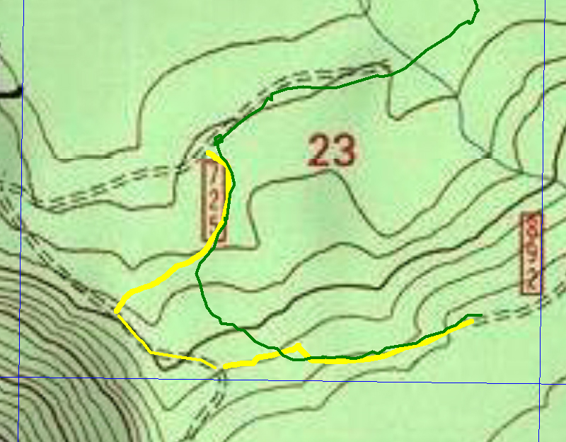

MEMBERSHIP RENEWAL:
It’s time again to renew your membership for the 2025-2026 season. For only $20 you receive access to all the inside club news, alerts, Ski School, upcoming tours and the satisfaction of supporting our efforts to promote and improve cross-country skiing for everyone. You can download a renewal form at https://oncwillamette.org/join-us/. Join us for a great season on the snow.
For those who prefer the electronic path there is a link for PayPal, where you will need to sign in with your PayPal account. We will try to get a guest pay option set up. But please email me a form so I will have all your information and waiver or fill in all that info on our website. The Zelle option is also set up by using my email or phone number. I’ve kept some past members on the roster/distribution list but if you want to be removed please let me know. Thanks, Bob Young

SKI SCHOOL:
Nothing definite yet, but we will arrange a date with Hoodoo’s Nordic instructors once they open for the season. It will probably be in late January or early February. Watch the Newsletter for details.

SNO-PARK PERMITS:
Sno Park permits may be purchased online at the Oregon DMV: https://dmv2u.oregon.gov/eServices/_/. Annual permits purchased directly from DMV cost $25—no handling fee. The process takes only a few minutes and includes a downloadable copy you can print and use immediately while waiting for your permit to arrive in the mail. Buy a permit and support Sno Park plowing.

CROSS-COUNTRY SKI RENTALS:
There is a limited supply of rental equipment for XC skiing in the Willamette Valley. Current sources and prices are listed below. Please send us an email, if you know of other local sources for rental gear. We will include it in a future Newsletter.

Hoodoo Ski Bowl  541-822-3799  https://skihoodoo.com/rates/rentals/ | $25/day | Rossignol no-wax touring skis
Peak Sports  207 NW 2nd St  Corvallis, OR 97330  541-754-6444  https://www.peaksportscorvallis.com/products/snowsports-rentals-pg252.htm | $25/48 hr  $30/48 hr | Rossignol no-wax touring skis  Rossignol metal-edged backcountry skis
Berg's Ski & Snowboard Shop  367 W 13th Ave  Eugene, OR 97401  541-683-1300  https://www.bergsskishop.com/?gclid=Cj0KCQiA7qP9BRCLARIsABDaZzhpIPR5kCINoWrmOLAwXP_hbuZlmART_5XUvDSUPJbWu_LK6fTylzAaAt2sEALw_wcB | $15/day, $10 2nd day  $25/day, $15 2nd day  $40/day, $30 2nd day | No-wax touring skis  Skate ski package  AT Package: skis, boots, poles & skins
Mountain Shop  1510 NE 37th Avenue  Portland, OR 97232  503-288-6768  https://www.mountainshop.net/rentals/nordic.html | $30/ two nights  $20/ two nights  $35 / two nights | No-wax touring skis  Kid’s touring skis  Metal-edged backcountry skis

OVERNIGHT TRIPS
The Portland Chapter of the Oregon Nordic Club invites members of other ONC chapters to join them Feb. 18-22, for “Best of NE Oregon Skiing From La Grande”. This is a great opportunity to experience powder skiing at Anthony Lakes, Meacham Divide and Horseshoe Prairie Nordic Ski Area. See details at https://onc-pdx.org/events/best-of-ne-oregon-skiing-from-la-grande/. Non-members of the Portland Chapter should contact the Trip Leader (Ken Barker) directly to sign up for the trip.
ANNOUNCEMENTS:
In our Announcement Section members can post ski items for sale, cross-country related questions, inquiries about conditions and suggestions for ski trips. Please send your announcemnts to Bob, Jim or Adria for inclusion in the Newsletter. Another good place for these items is on the website, oncwillamette.org.

(Although there are no snow photos this month we can at least offer pictures of some very nice skis)
1. Abe Quihius, retired Wilderness Ranger for the Detroit RD, has backcoutry gear for sale: Karhu Tour skis with Rottefella cable bindings and Merrell leather boots. Contact Abe at mailto:aquihius@wbcable.net if you are interested.

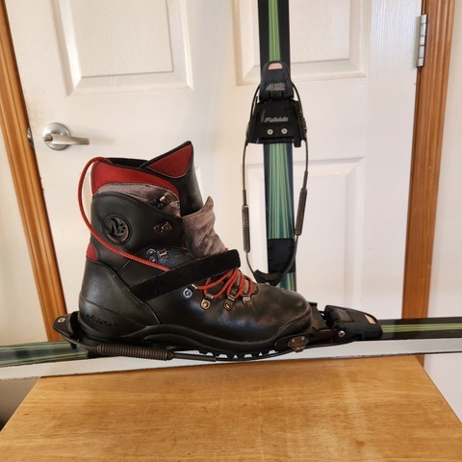
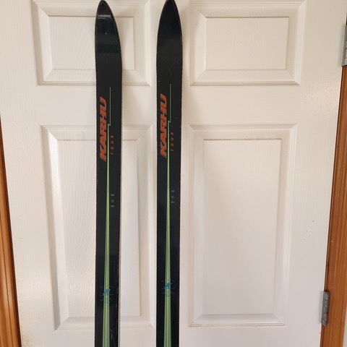

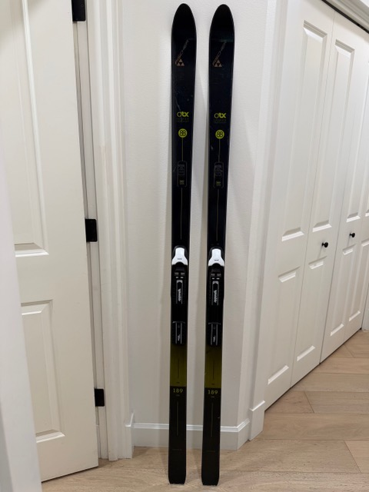
2. Rob Titcomb is selling his Fischer Excursion 88 skis (189cm) with NNN/BC manual bindings; also a brand new pair of Madshus Glittertind BC boots (size 11). If interested you can reach Rob at mailto:robtitcomb@gmail.com,
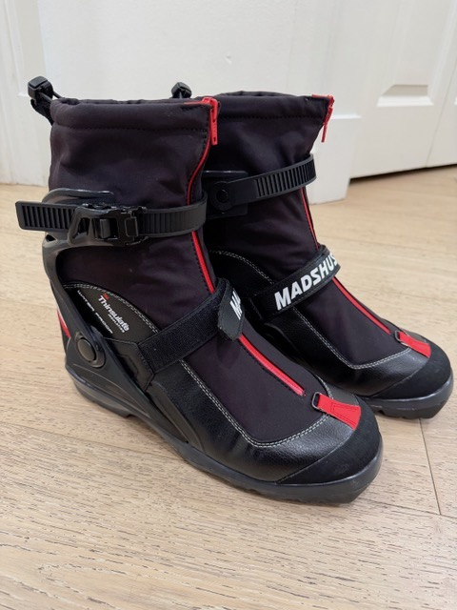

2025-2026 OFFICERS & BOARD MEMBERS:
Vacant President
Jeanne Miller Vice President
Adria Buncal Webmeister
Vacant Newsletter Editor
Jim Todd Day Tour Chair
David Forkner ONC State Board Rep & Board Member
Pam Wojcik Overnight Trip Coordinator & Board Member
Vacant Volunteer Coordinator & Board Member

Christine Young Board Member
John Hortsch Board Member

